Lab no 09

High-Level Language Interface
Program no 01:
int dot_product(short a[], short b[], int N)
{
int i, sum = 0;
for (i = 0; i < N; i++)
{
sum += a[i] * b[i];
}
return sum;
}

void main(void)
{
short a[8] = { 10, 20, 30, 40, 50, 60, 70, 80 };
short b[8] = { 100, 200, 300, 400, 500, 600, 700, -800 };
int csum;

csum = dot_product(a, b, 8);
}
Output:

Lab Work
- Write, build, and debug the provided mixed C and assembly dot product code.
Program:
#include <stdio.h>

int dot_product(short a[], short b[], int N)
{
int i, sum = 0;

for (i = 0; i < N; i++)
{
sum += a[i] * b[i];
}
return sum;
}

int dot_product_asm_inline(short a[], short b[], int N)
{
int sum = 0;

__asm {
pushfd; save flags

mov esi, a; esi = address of a
mov edi, b; edi = address of b
mov ecx, N; loop counter
xor eax, eax; eax = 0 (sum)

LOOP_START:
cmp ecx, 0
je END_LOOP

movsx ebx, WORD PTR[esi]; ebx = a[i]
movsx edx, WORD PTR[edi]; edx = b[i]

imul ebx, edx; ebx = a[i] * b[i]
add eax, ebx; sum += product

add esi, 2; next short(2 bytes)
add edi, 2

dec ecx
jmp LOOP_START

END_LOOP :
mov sum, eax; store result
popfd; restore flags
}

return sum;
}

int main(void)
{
short a[8] = { 10, 20, 30, 40, 50, 60, 70, 80 };
short b[8] = { 100, 200, 300, 400, 500, 600, 700, -800 };

int csum, aisum;

csum = dot_product(a, b, 8);
aisum = dot_product_asm_inline(a, b, 8);

printf("C sum = %d\n", csum);
printf("ASM sum = %d\n", aisum);

return 0;
}
Output:
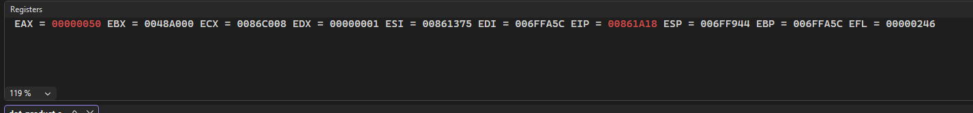
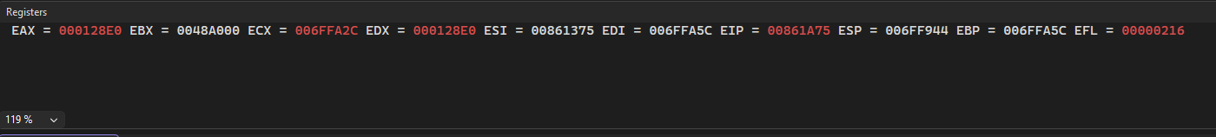
Task no 02:
Write, build, and debug the provided C with inline-assembly dot product code.
Program:
#include <stdio.h>

int dot_product_asm_inline(short a[], short b[], int N)
{
int sum = 0;

__asm {
pushfd; save flags

mov esi, a; pointer to array a
mov edi, b; pointer to array b
mov ecx, N; loop counter
xor eax, eax; eax = sum = 0

LOOP_START:
cmp ecx, 0
je END_LOOP

movsx ebx, WORD PTR[esi]; load a[i]
movsx edx, WORD PTR[edi]; load b[i]

imul ebx, edx; multiply
add eax, ebx; add to sum

add esi, 2; move to next element
add edi, 2

dec ecx
jmp LOOP_START

END_LOOP :
mov sum, eax; store result
popfd; restore flags
}

return sum;
}

int main()
{
short a[5] = { 1, 2, 3, 4, 5 };
short b[5] = { 10, 20, 30, 40, 50 };

int result;

result = dot_product_asm_inline(a, b, 5);

printf("Dot Product = %d\n", result);

return 0;
}
Output:
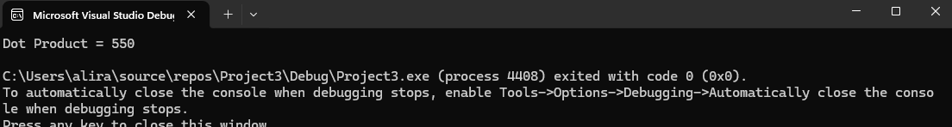
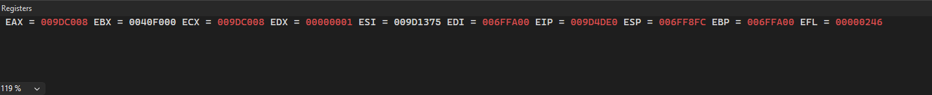
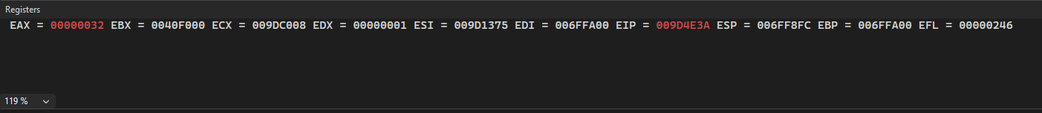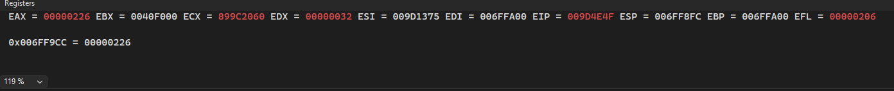

Exercise
- Hamming Weight
It is the number of ones (bits having value of one) in a given number. So the hamming weight of 37 is 3, while that of 4659 is 6

- Write a function ham_weight() which can have the prototype as follows;
int ham_weight( unsigned long num);

Program:
#include <stdio.h>

int ham_weight(unsigned long num)
{
int count = 0;

while (num > 0)
{
if (num & 1) //
count++;

num = num >> 1;
}

return count;
}

int main()
{
unsigned long n1 = 37;
unsigned long n2 = 4659;

printf("Hamming Weight of %lu = %d\n", n1, ham_weight(n1));
printf("Hamming Weight of %lu = %d\n", n2, ham_weight(n2));

return 0;
}
Output:
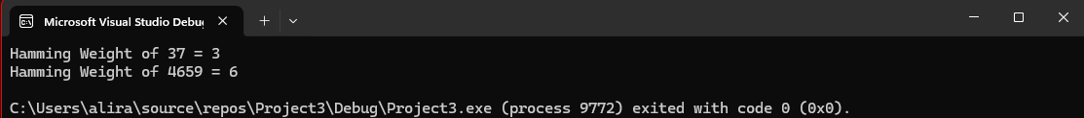
Task no 02
Write, build, and debug the above function in C with inline-assembly code.
Program:
#include <stdio.h>

int ham_weight(unsigned long num)
{
int count = 0;

while (num > 0)
{
if (num & 1) //
count++;

num = num >> 1;
}

return count;
}

int main()
{
unsigned long n1 = 37;
unsigned long n2 = 4659;

printf("Hamming Weight of %lu = %d\n", n1, ham_weight(n1));
printf("Hamming Weight of %lu = %d\n", n2, ham_weight(n2));

return 0;
}
Output:
Task no 03:
Write, build, and debug the above function in mixed C and assembly code.
Program:
#include <stdio.h>
int ham_weight(unsigned long num)
{
int count = 0;

__asm {
mov eax, num
xor ecx, ecx

LOOP_START :
cmp eax, 0
je END_LOOP

mov edx, eax
sub edx, 1
and eax, edx

inc ecx
jmp LOOP_START

END_LOOP :
mov count, ecx
}

return count;
}

int main()
{
unsigned long n1 = 37;
unsigned long n2 = 4659;

printf("Hamming Weight of %lu = %d\n", n1, ham_weight(n1));
printf("Hamming Weight of %lu = %d\n", n2, ham_weight(n2));

return 0;
}
Output:
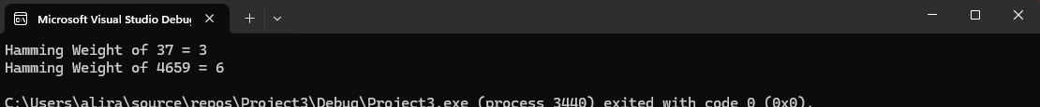
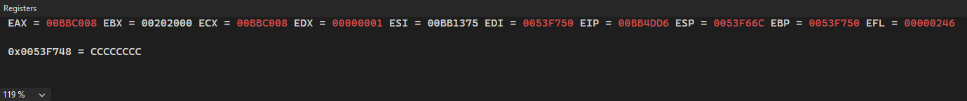
Lab